Workplace Health and Safety Workbook

Contribute to Health and Safety of Self and Others
For this actively you will participate in two work activities that contribute to the health and safety of yourself and others.

- Maintain a clean work area and check for hazards
Game developers work with expensive computer equipment, which means it its important to keep our work area clean and clear of anything that could cause damage to our equipment – like open drink containers.
Garbage, foodscraps, and other debris can attract vermin which, in addition to being unhygienic, could result in additional damage to electrical cabling and components through chewed cabling or other damage.
Clean up your work area and do a visual inspection of the external components and cables of your equipment. Ensure powerboards and electrical outlets are not overloaded, and cabling does not present a trip hazard.
Take a photo of your work area using your phone or digital camera and insert it below.
If you identified any problems, make sure to inform your trainer or supervisor.
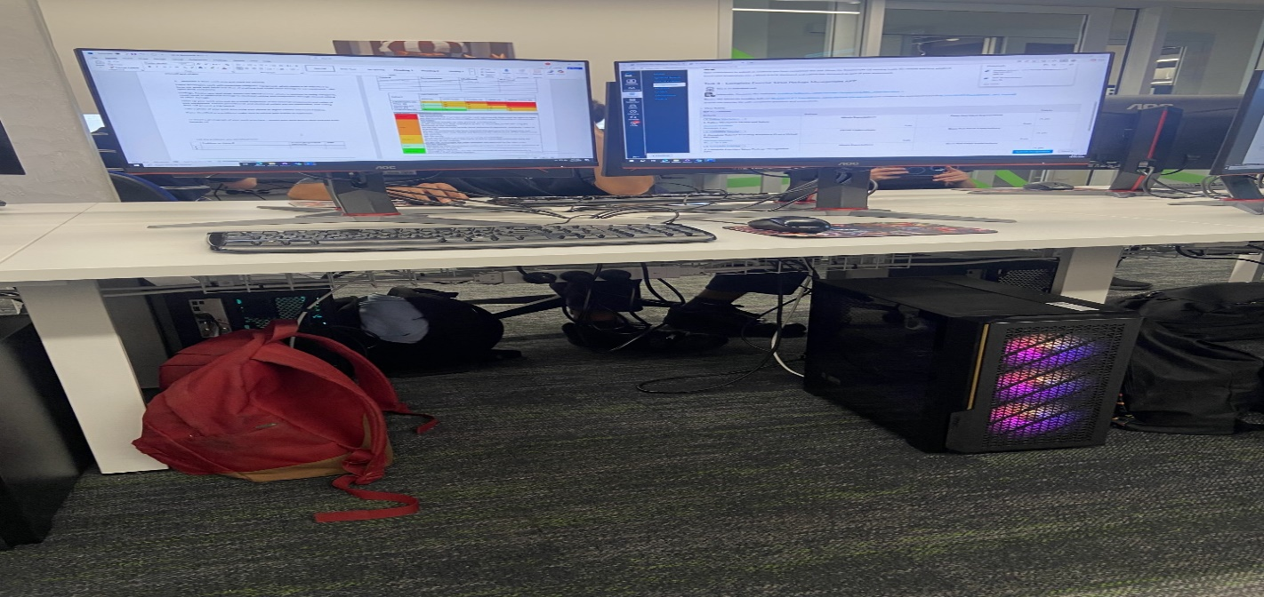

List any problems you identified here:
 | Problem or Hazard | Trainer/Supervisor  Informed | Date
1
2

- Complete a workplace safety audit
Identify at least 3 hazards in your workspace (in addition to the example). List each hazard in the table below.
Use the Risk Matrix below to measure the risk level of each hazard.
Hazard | Consequence | Likelihood | Risk Level
Boxes on the floor | Trip hazard (minor) | Possible (3) | Medium
Faulty wiring | Electrocution (catastrophic) | Unlikely (1) | Medium
Poor posture | Disability (moderate) | Likely (4) | Medium
Eye strain | Loss of eyesight (moderate) | Possible (3) | Medium

IMPACT | LIKELIHOOD
 | Rare (1) | Unlikely (2) | Possible (3) | Likely (4) | Almost Certain (5)
Catastrophic (A) | M | M | H | C | C
Major (B) | L | M | M | H | C
Moderate (C) | L | M | M | M | H
Minor (D) | L | L | M | M | M
Insignificant (E) | VL | VL | L | L | M

Risk level | Required action
Critical | Act immediately:  The proposed task or process activity must not proceed. Steps must be taken to lower the risk level to as low as reasonably practicable using the hierarchy of risk controls.
High | Act today:  The proposed activity can only proceed, provided that:  (i) the risk level has been reduced to as low as reasonably practicable using the hierarchy of risk controls;  (ii) the risk controls must include those identified in legislation, Standards, Codes of Practice etc.  (iii) the risk assessment has been reviewed and approved by the Supervisor and  (iv) The supervisor must review and document the effectiveness of the implemented risk controls.
Medium | Act this week:  The proposed task or process can proceed, provided that:  (i) the risk level has been reduced to as low as reasonably practicable using the hierarchy of risk controls;  (ii) the risk assessment has been reviewed and approved by the Supervisor.
Low | Act this month:  Managed by local documented routine procedures which must include application of the hierarchy of controls.
Very Low | Keep a watching brief:  Although the risk level is low the situation should be monitored periodically to determine if the situation changes.

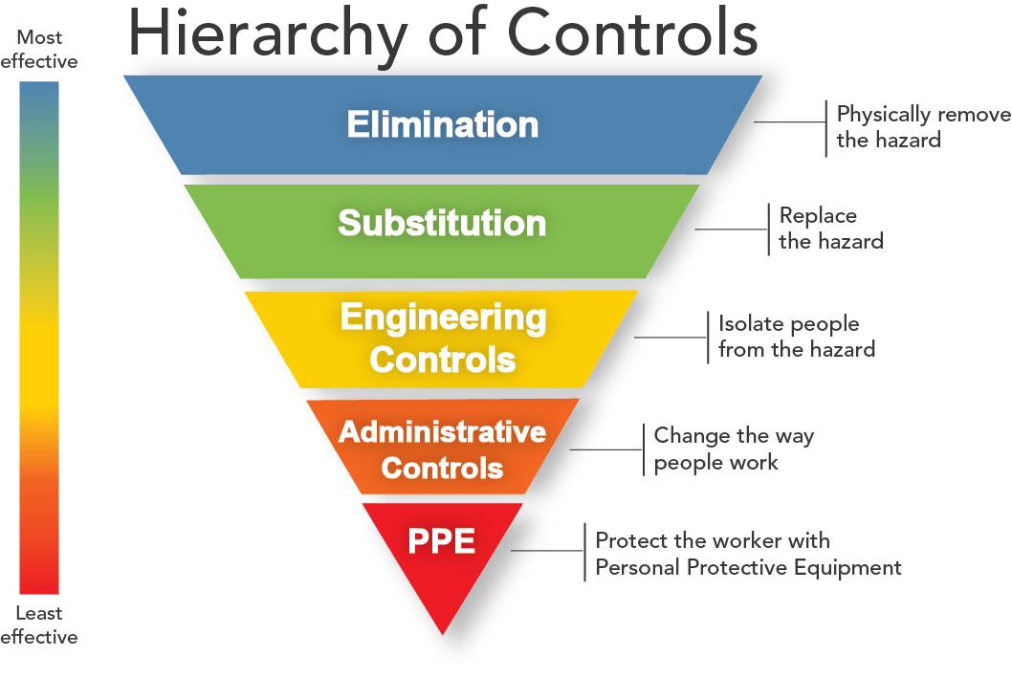
For each hazard you identified above, identify a method to control the risk of the hazard.
Try to use one of the more effective methods of control first. If that is not possible, use a less effective method.
Complete the table below, listing one or more control methods for each hazard you identified.
Hazard | Control Method
Boxes on floor (trip hazard) | Stack boxes in corner of room or put in closet
Faulty wiring (Electrocution) | Check wires frequently, replace faulty
Poor posture (Disability) | Ensure proper posture, personalise back supports
Eye strain (Eye sight loss) | Ensure proper work process, reduce unwanted light sources.

Identify and Report One Hazard
Most workplaces have a formal method for reporting a hazard or concern.
Using one of the hazards you identified in your workplace safety audit, complete the following workplace hazard report.
If you feel the hazard you identified poses an immediate risk to the safety of yourself and other learners, give this report to student administration or the local campus Head of School. Otherwise your trainer will follow up on any safety issues.

Hazard/Incident Report Form
Use this form in your workplace to report health and safety hazards and incidents.

Hazard/Incident
Brief description of hazard/incident: (Describe the task, equipment, tools and people involved. Use sketches, if necessary. Include any action taken to ensure the safety of those who may be affected.)
Eye strain from computer monitors being used for long durations
Where is the hazard located in the workplace?
Main work tasks
When was the hazard identified? | Date: 16/4/2026 | Time: 10:17 AM
Recommended action to fix hazard/incident: (List any suggestions you may have for reducing or eliminating the problem – for example re-design mechanical devices, update procedures, improve training, maintenance work)
Install blinds, ensure people know how to keep their eyes safe.

Date submitted to manager: | Date: | Time:

Action taken
Has the hazard/incident been acknowledged by management? Yes/ No
Describe what has been done to resolve the hazard/incident:
Do you consider the hazard/incident fixed? Yes / No
Name: | Position:
Signature:

Date:

Recognising the Signs
For each of the following signs that you might see around the workplace record next to each what it is referring to.
 | Wet floor sign  This means there could be wet floors.
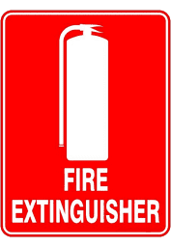 | Fire extinguisher sign  This means that there is a fire extinguisher
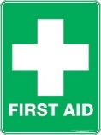 | First aid sign  This means that there is first aid here
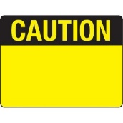 | CAUTION sign  This is a warning.

Fire Safety
Head to the following link and answer the following questions, it goes to a page describing the 10 measures to increasing Fire Safety.
https://www.amsj.com.au/fire-safety-measures-workplace/
List each of the measures and in your own words, briefly describe each one
Identifying fire hazards: Identify what can be fuel, what can be an igniter.
Identifying employees at risk: Ensure fire extinguishers are checked visually monthly and are maintained annually.
Inspecting smoke detectors and fire alarms: Make sure that fire alarms are installed and working.
Checking electrical equipment: Look at wires monthly.
Checking evacuation routes: Make sure there are multiple fire exits and employees know where to go in the case of a fire.
Undergoing fire safety awareness training: Train staff in fire safety.
Preparing emergency plans: Have an emergency plan that is easy to explain and remember.
Using a reliable fire protection service: Hire a company to do your fire safety for you.
Staying up to date with fire safety: Look for fire hazards, do all the above.

How often do fire extiguishers require internal maintenance?
Every five years.

Now head to this final link: https://www.fire.nsw.gov.au/page.php?id=74
In your own words describe what to do in the event of a fire based on the RACE acronym
Make sure everyone it is safe to save is safe, then notify everyone you can, then make sure to stop the spread of fire, then see if its possible to extinguish it.

